EXPERIMENT 7:
MOSFET Scaling Analysis and Subthreshold Swing Calculation using
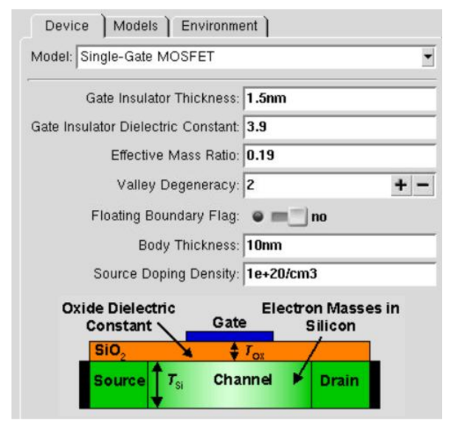
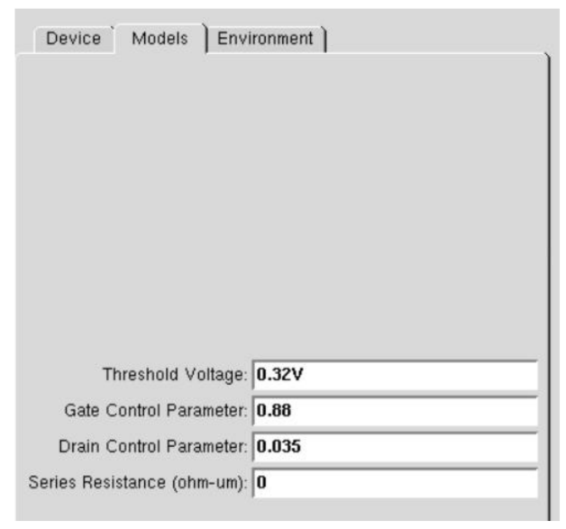
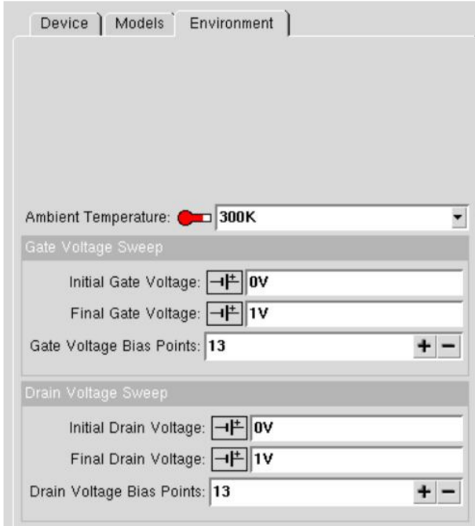
Case 1: Increase in VG :
● Observation: As VG increases, the drain current (ID ) also increases exponentially
due to the MOSFET entering the saturation region earlier.
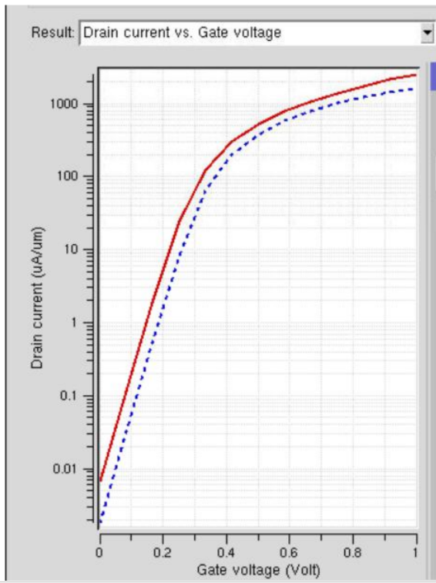
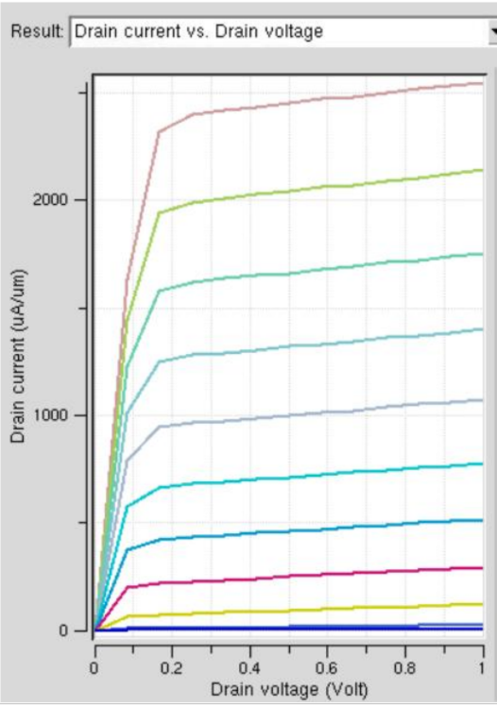
This case study is performed to analyze the effect of increasing gate voltage (VG) on the drain current (ID) of a FET. It helps understand how the gate voltage controls the flow of charge carriers in the channel.

Case 2: Variation in VD :
● Observation: Drain current (ID ) saturates for higher VD at a fixed VG .
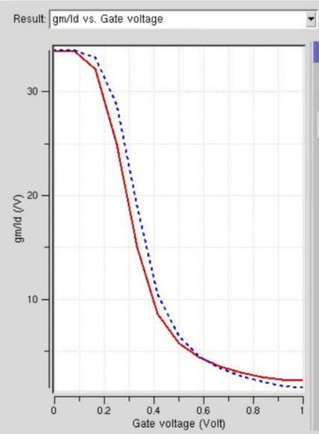
This case study is performed to analyze the effect of changing drain voltage (VD) on the drain current (ID) of a FET while keeping gate voltage (VG) constant. It helps understand the different operating regions of a MOSFET.

